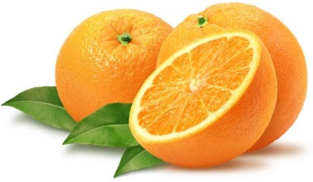
Woodford County Farm Bureau
2016 Florida Citrus Sale
Order Deadline is Thursday, November 17th!
Citrus Price Quantity Cost
4/5 bu. Navel Oranges $32.00
4/5 bu. Grapefruit $25.00

Additional Fruit
2/5 bu. Grand Slam Gift Box $27.00
(6 Red Delicious Apples, 6 Di Anjou Pears, 3 Golden Delicious Appels, 16-20 Navel Oranges)
2/5 bu. Tri Pack $27.00
(10 Navel oranges, 11 grapefruit, and 10 Red Delicious Apples)

Nuts
16 oz. Skinless Peanuts $4.50
9 oz. Roasted Almonds $6.00
12 oz. Honey Krunch Peanuts $4.00
12 oz. Peanut Brittle Bites $4.50
12 oz. Butter Toffee Peanuts $4.00
16 oz. Shelled Pecans $11.00

Cheese
5 lb. Baby Swiss $26.00
2.5 lb. Baby Swiss $14.00
1 lb. Baby Swiss $6.00
1 lb. Aged Swiss $5.50
1 lb. Mild Brick $5.00
1 lb. Feta $4.00
1 lb. Pepper Jack $5.50
1 lb. Colby Longhorn $5.00
1 lb. Cheddar $5.50
1 lb. Cojack $5.00
2 lb. Farmers $10.00
½ lb. String Cheese $3.00
5 lb. American Cheese Slices $13.00
16 oz. Cheese Spread $6.50
11 oz. Beef Summer Sausage $4.75

Special Gift Items
Buttery Caramel Corn w/ nuts $10.00
(20 oz. tins)
Berry Nut Trail Mix $10.00
(15 oz. tins)
Total Quantity and Cost

Please Include Payment with your order. Thank you.
Mail or Bring to: Woodford County Farm Bureau Name:
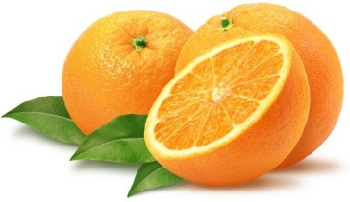
P.O. Box 225, 117 W. Center Street
Eureka, IL 61530 Phone Number:

Tentative pickup date set for December 13, 2016

