Woodford County Farm Bureau
2019 Citrus Sale Order Form
Order Deadline is Friday, November 8, 2019!
Pickup is Tuesday, December 17, 2019
Pick up at Evergreen FS Plant, 966 County Rd 1625 E, Eureka, IL 61530, 9 a.m. – 11 a.m.

Citrus Price Quantity Cost
4/5 bu. Navel Oranges $38.00 _______ ______
2/5 bu. Navel Oranges $24.00 _______ ______
4/5 bu. Red Grapefruit $33.00 _______ ______
2/5 bu. Red Grapefruit $19.00 _______ ______
1/2 bu. Clementines $40.00 ______
1/5 bu. Clementines $20.00 _____

*(4/5 bushel is approximately 50-60 oranges, 30-40 grapefruit)

Nuts
16 oz. Skinless Peanuts $5.00
9 oz. Roasted Almonds $6.00
12 oz. Honey Krunch Peanuts $5.00
12 oz. Peanut Brittle Bites $6.00
12 oz. Butter Toffee Peanuts $5.00
16 oz. Shelled Pecan Halves $12.00
16 oz. Whole Cashews $12.00

Cheese
5 lb. Baby Swiss $40.00
2.5 lb. Baby Swiss $20.00
1 lb. Baby Swiss $8.00
1 lb. Swiss $7.00
1 lb. Mild Brick $7.00
1 lb. Pepper Jack $7.00
1 lb. Longhorn $7.00
1 lb. Sharp Cheddar $8.00
1 lb. Mild Cheddar $7.00
2 lb. Mozzarella $12.00
2 lb. Farmers Cheese $13.00
1 lb. String Cheese $7.00
1 lb. Calico $7.00
5 lb. American Sliced $19.00

12 oz. Beef Summer Sausage $5.00

Total Quantity and Cost:

Please Include Payment with your order. Thank you!
Mail or Bring to: Woodford County Farm Bureau Name:
P.O. Box 225, 117 W. Center Street
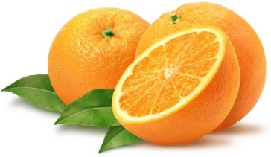
Eureka, IL 61530 Phone Number:

Citrus Pickup December 17, 2019

